Steps I took to get matplotlib working with buildozer:

Went to this website:  
<https://github.com/kivy/python-for-android/issues/2262>

Followed these directions:

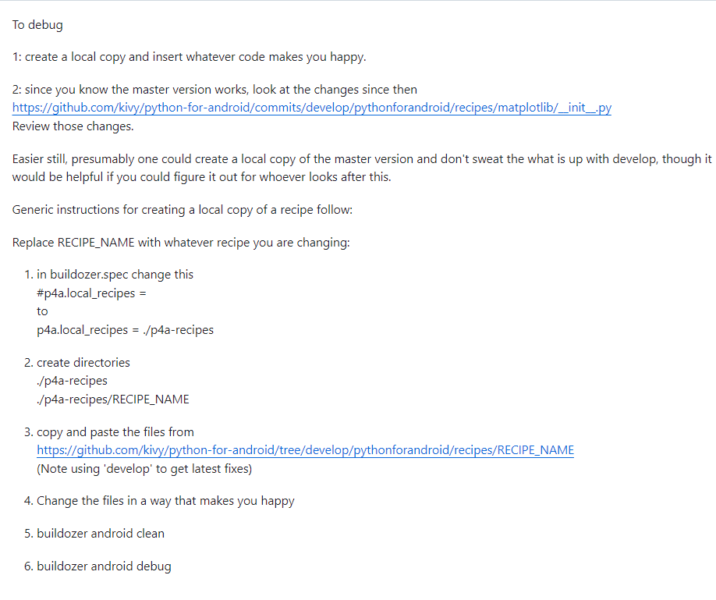

Copied old version of matplotlib recipe __init__.py file and pasted it into ./p4a-recipes/matplotlib:  
<https://github.com/kivy/python-for-android/blob/17395de925a87485e67ff418a5c97e01d7d30481/pythonforandroid/recipes/matplotlib/__init__.py>

Saved buildozer.spec and ran buildozer -v android debug from terminal in vscode/wsl2